**How to get to CT STATE Asnuntuck**

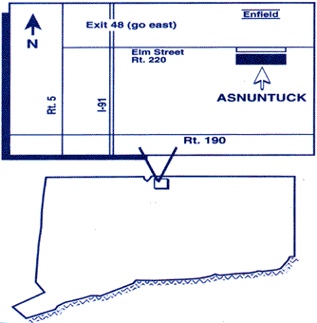

**From the South**

Take 91 Northbound to Exit 48. Turn Right at the end of the ramp onto Route 220 (Elm Street). Travel East through five traffic lights. The college will be on the right. When entering the driveway, take the first right in the rotary. Proceed to the back of the front building until you see the manufacturing building in the back. Parking is available directly in front of the building or any place within the large parking lot. Please sign into the manufacturing building and the office is on the left after the entry.

**From the North**

Take 91 Southbound to Exit 48. Turn Left at the end of the ramp onto Route 220 (Elm Street). Continue with directions as above from the South. Asnuntuck will be on your right. When entering the driveway, take the first right in the rotary. Proceed to the back of the front building until you see the manufacturing building in the back. Parking is available directly in front of the building or any place within the large parking lot. Please sign into the manufacturing building and the office is on the left after the entry.

